5.71: a) Forces on you:

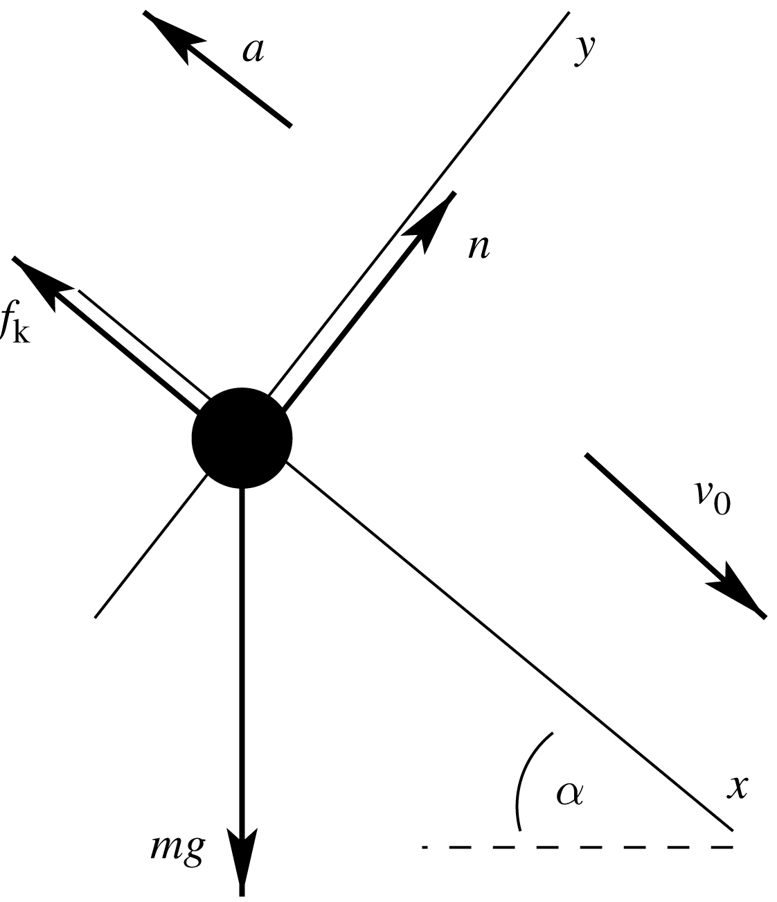
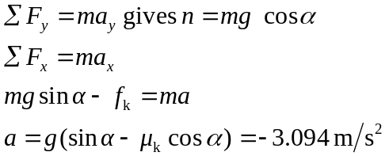
Find your stopping distance
which is greater than 40 m. You don’t stop before you reach the hole, so you fall into it.
b)

